SUB (Query)

A sub query (or sub-query) is a query nested inside another query. It is commonly used in databases (such as SQL) to provide data that the main query needs.
Two type of method

*.Co_Related
*.Non_Co_Related

- Co_Related

A co related sub query is a sub query that depends on values from the outer query. It is evaluated once for each row processed by the outer query.

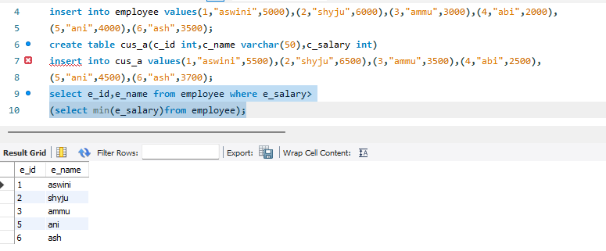

- Non_Co_Related

A non-co-related sub query is a sub query that does not depend on the outer query. It can be executed independently and usually runs only once before the outer query is processed.

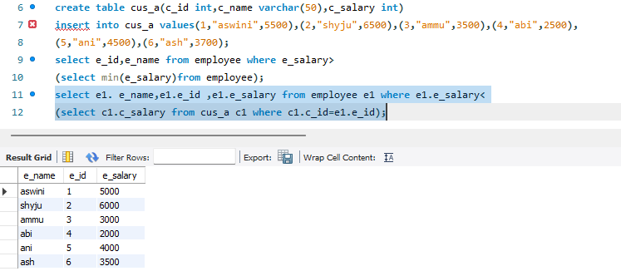

Types of Sub query

*Single row
*Multi row
*Inline view
*Scalar row
*Hierarchy row

- Single row:

A single-row sub query is a sub query that returns only one row and one value to the outer query.
<,>,<=,>=,=,<>

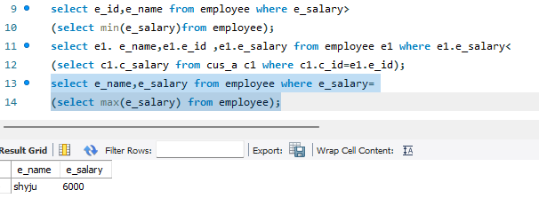

- Multi row:

A multi-row sub query is a sub query that returns more than one row of results to the outer query.
IN,ANY,ALL.
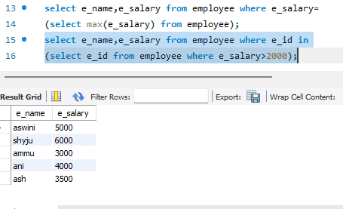

- Inline view:

An inline view is a subquery written in the FROM clause of a SQL statement. The result of the subquery is treated like a temporary table that can be queried by the outer statement.

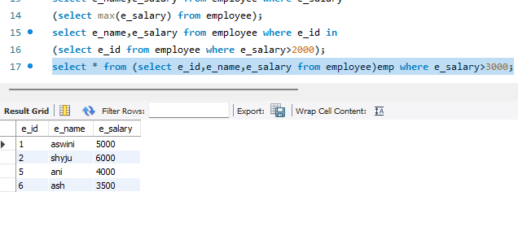

4.Scalar row

A scalar subquery is a subquery that returns exactly one row and one column (a single value). This value can be used wherever a single value or expression is allowed in SQL.

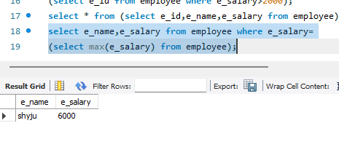

5.Hierarchy row

A hierarchical query is a query used to retrieve data that has a parent-child relationship, such as organizational structures, family trees, or category hierarchies.

